**TRINITY INTERNATIONAL SS & COLLEGE**

**Dillibazar Height, Kathmandu, Nepal**



**LAB WORK # 1: Application Package (MS-Excel)**

**(COMPUTER SCIENCE)**

**SUBMITTED BY: SUBMITTED TO:**

**NAME: Prashim Timsina**

**GRADE: XI (MC1)**

**DATE : [2079/07/18] PRAVEEN KOIRALA**

**Faculty of Computer Science**

**KATHMANDU, NEPAL**

**2022 Table of Contents**

S. No. Page No.

1. Acknowledgement I

2. Objectives II

3. Table of Contents III

4. Theoretical Background (1)

4.1 Application Package

4.1.1 MS-EXCEL

5. Work Done

5.1 Formatting Cells 2

5.2 Applying Formulas 3

5.3 Applying data in specific cells 4

6. Conclusion

7. Bibliography

8. Appendix

**2. Objective**

The main objectives of the lab work are as follows:

1. To understand worksheet, row, column and cell.
2. Enter data into specific cells with different formats.
3. To practice applying formulas.

**3. Theoretical Background**

=> Application Package: Microsoft Office, or simply Office, is the former name of a family of client software, server software, and services developed by Microsoft.

MS Excel: MS Excel is a spreadsheet program where one can record data in the form of tables. It is easy to analyze data in an Excel spreadsheet

Cell: A spreadsheet is in the form of a table comprising rows and columns. The rectangular box at the intersection point between rows and columns forms a cell.

Cell Address: The cell address is the name by which is cell can be addressed. For example, if row 7 is interested in column G, then the cell address is G7.

Home: Comprises options like font size, font styles, font color, background color, alignment, formatting options and styles, insertion and deletion of cells and editing options

Insert: Comprises options like table format and style, inserting images and figures, adding graphs, charts and sparklines, header and footer option, equation and symbols.

Page Layout: Themes, orientation and page setup options are available under the page layout option

Formulas: Since tables with a large amount of data can be created in MS excel, under this feature, you can add formulas to your table and get quicker solutions

Data: Adding external data (from the web), filtering options and data tools are available under this category.

Page: 1

**4. Work Done**

1) Making a table using default formatting such as merge, formatting, border, highlight, bold, center, left align, etc.

The following can be accessed by, selecting the desired cells and right clicking it and clicking it on the format tab. All the above-mentioned tools can be accessed there.

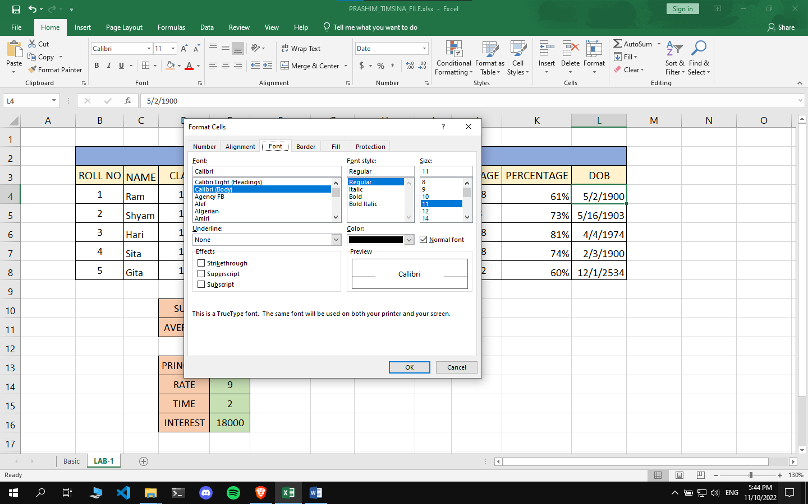

Page: 2

2) Different formulas such as sum, average, percentage, interest can be used in MS-Excel by providing “=” parameter.

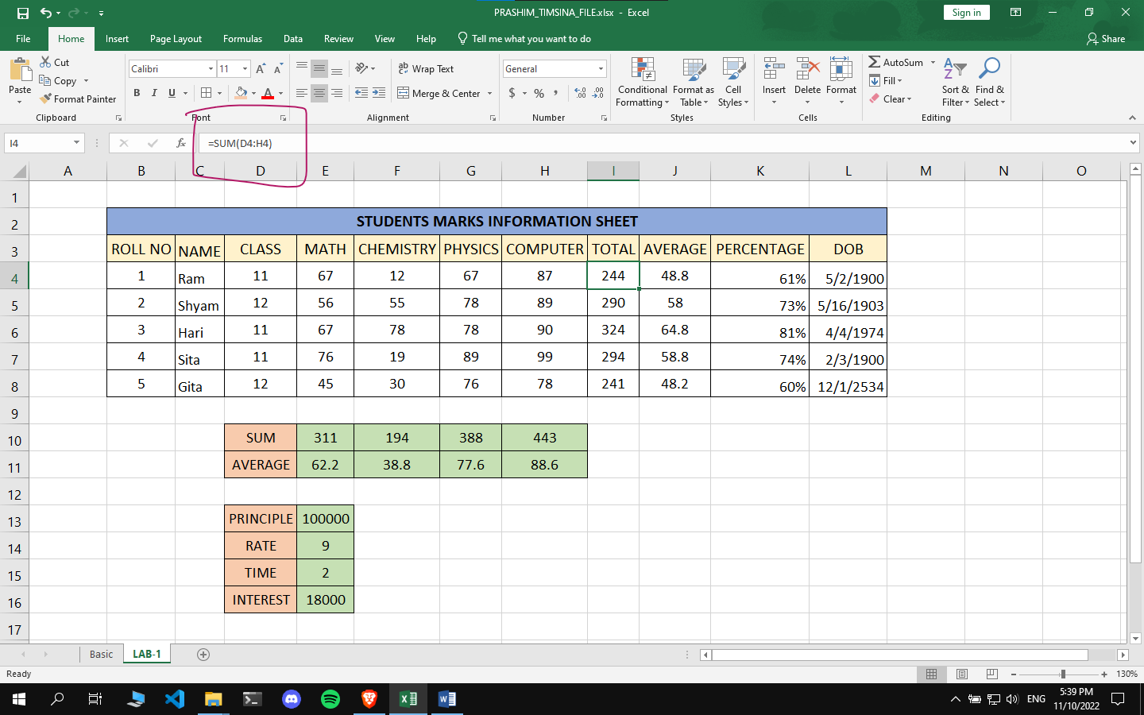

Page: 3

3) We can enter a specific type of data in the cell by using the format cell button as above:

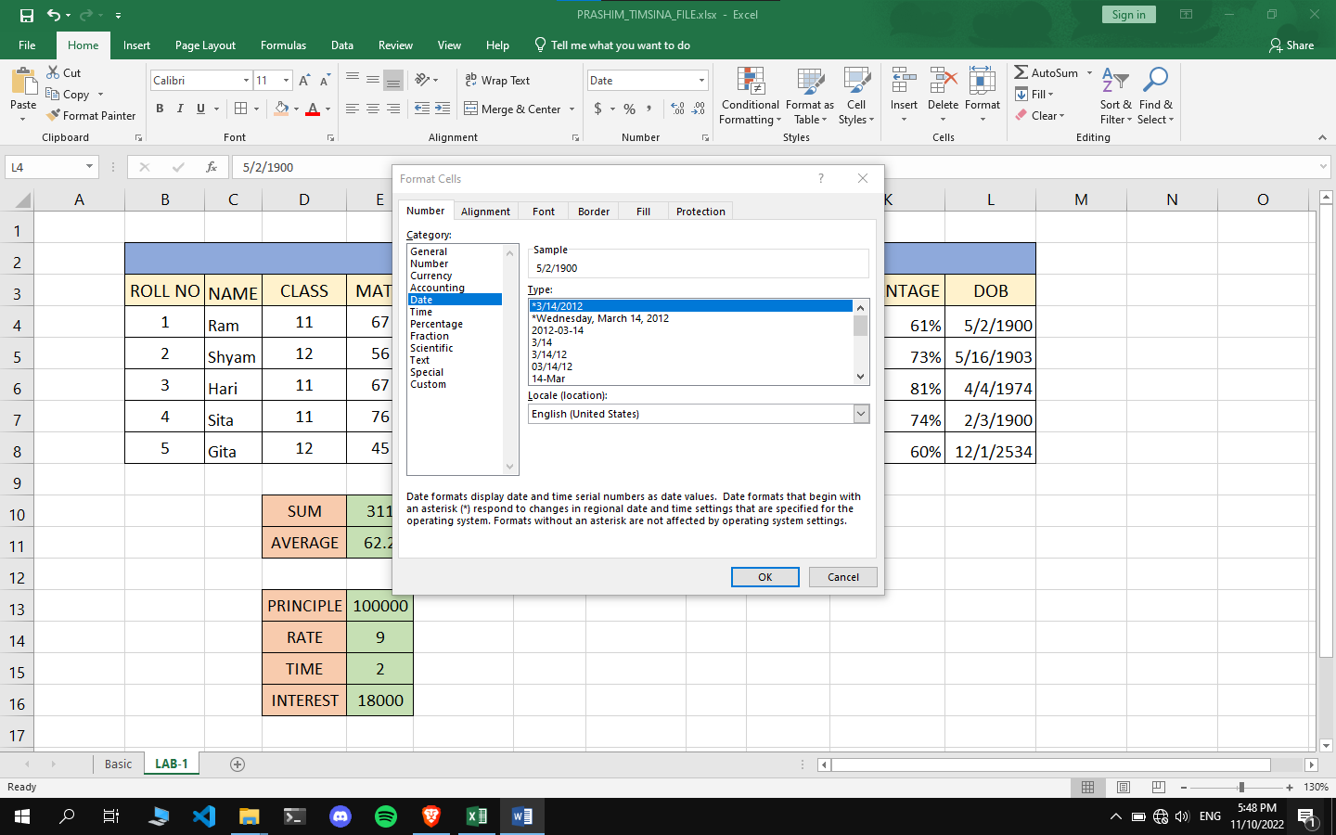

Page: 4